1. Pick any mobile app you use daily (like Zomato, Instagram, or Paytm), open its login or signup form, and identify 5 possible defects in the UI or workflow. Write each defect as a clear defect statement.
Ans:
Example: Paytm Login Form – 5 Possible UI/Workflow Defects
Defect ID | Defect Statement
DEF-01 | The Login/Continue button remains enabled when the mobile number field is blank, allowing the user to proceed without entering required data.
DEF-02 | The mobile number field accepts alphabetic or special characters, instead of restricting input to a valid 10-digit mobile number.
DEF-03 | When an invalid OTP is entered, the application does not display a clear error message explaining that the OTP is incorrect.
DEF-04 | After entering an expired OTP, the user is not provided with a clearly visible Resend OTP option or instructions to request a new OTP.
DEF-05 | The error message is displayed far away from the affected input field, making it difficult for the user to identify and correct the invalid entry.
These are written as clear, testable defect statements suitable for a QA assignment.

2. For each defect you found in the previous task, assign a Severity level (Blocker, Critical, Major, Minor, Trivial) and a Priority level (High, Medium, Low). Briefly justify your choice for one defect where severity and priority are different.<br><br><em><strong>Hint:</strong> Think about how badly the defect impacts users (severity) versus how quickly it should be fixed (priority).</em>
Ans:
Paytm Login Form – Severity and Priority
Defect ID | Defect Statement | Severity | Priority | Reason
DEF-01 | Login/Continue button remains enabled when the mobile number field is blank. | Major | High | Users can proceed without required information, causing an incorrect workflow.
DEF-02 | Mobile number field accepts alphabetic or special characters instead of only a valid 10-digit number. | Major | High | Invalid input can cause login failures and affects a basic validation rule.
DEF-03 | No clear error message is displayed when an invalid OTP is entered. | Minor | Medium | Login may still be protected, but poor feedback makes it harder for users to recover.
DEF-04 | No clearly visible Resend OTP option or instructions are provided after an expired OTP. | Major | High | Users may be unable to complete login, directly blocking the authentication workflow.
DEF-05 | Error message appears far from the affected input field. | Minor | Low | The function still works, but the UI becomes confusing and less usable.
Severity vs. Priority Example
For DEF-03, severity is Minor but priority is Medium. The defect does not prevent the system from rejecting an incorrect OTP, so its functional impact is relatively low. However, OTP login is a common entry point, so providing a clear error message should be addressed reasonably soon to reduce user confusion.

3. Draw a Bug Life Cycle diagram showing all the main states (New, Assigned, Open, Fixed, Retest, Verified, Closed, Rejected, Deferred, Duplicate, Not a Bug) and the transitions between them. You can use pen-paper and upload a photo, or use any diagram tool you like.
Ans:
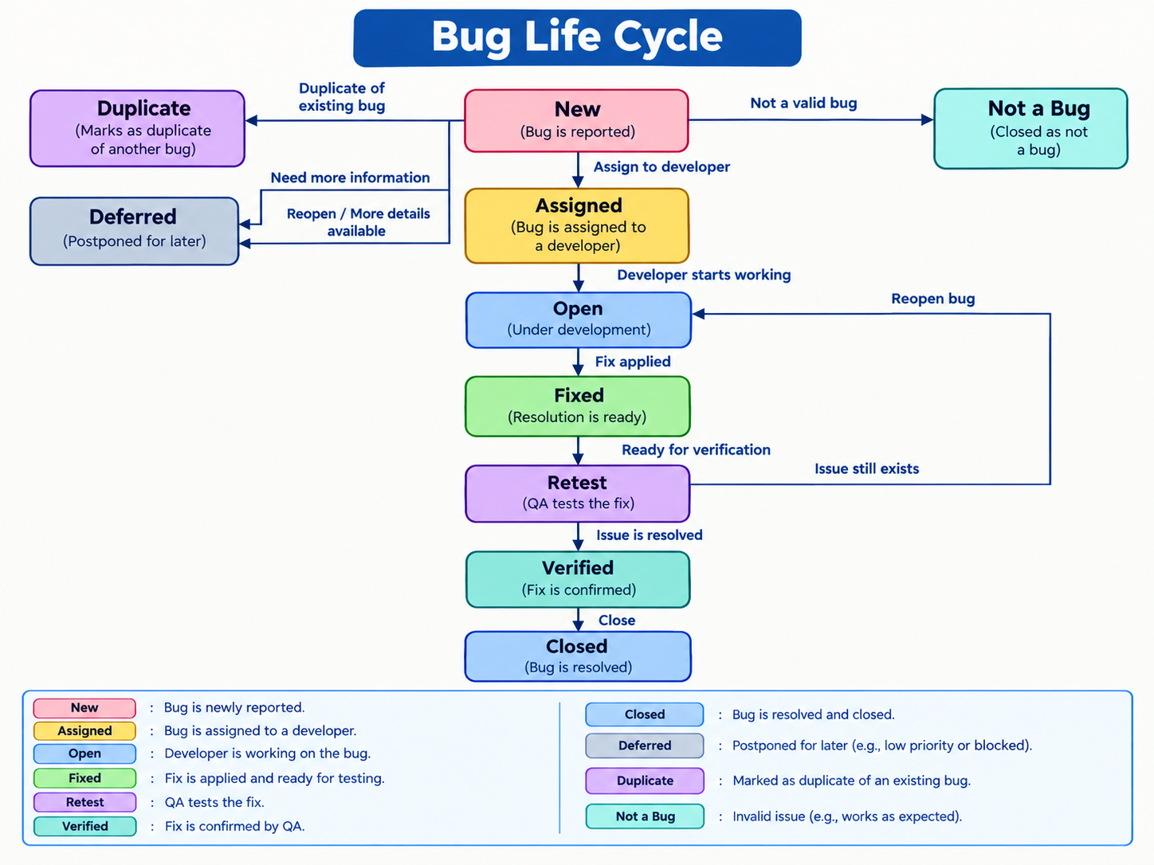
4. Write a short scenario where a defect in a UPI payment feature (like in PhonePe or Paytm) is found very late—after the app is live. Explain in 4-5 lines how the cost and impact of fixing this defect would be different if it was caught during development instead.
Ans:
Scenario: Late Defect in UPI Payment
A defect is found in a UPI payment feature after the app has gone live: payments occasionally show “failed” to the user even though the bank account was debited.
At this stage, fixing it requires urgent development, testing, deployment, customer support, and possibly refund/reconciliation work.
It can also affect many real users and reduce trust in the payment service.
If the defect had been detected during development, developers could fix the code before release and QA could retest it in the same environment.
The development-stage fix would generally require less time and cost and would avoid most production-user impact.

